Ergonomics Program – Office Environment | Revision Date: 02-2023
Purpose: To aid in reducing discomfort and injuries that are a result of ergonomic risk factors in the work environment. | Topics Covered  - Responsibilities of Staff  - Definitions  - Program Elements  - Sample Evaluation Reports

An effective ergonomics program can aid in reducing the discomfort and injuries that are a result of ergonomic risk factors in the work environment. [ORGANIZATION NAME] is committed to maintaining a safe and comfortable workplace for our employees. Our [TITLE OF RESPONSIBLE EMPLOYEE] is responsible for implementing this program at all company sites in addressing the issue of musculoskeletal disorders.

Under this program, the [TITLE] will complete an ergonomics hazard assessment to evaluate jobs or processes that have exposure to repetitive motion injuries (RMIs) through a worksite evaluation, claims history data, and observation.

This office ergonomics program will address the following areas:

- Responsibilities
- Definitions
- Program Elements
  - Worksite Evaluations
  - Evaluations request by a Physician
  - Ergonomic Evaluation Report
  - Workstation Ergonomic Handbook
  - Controls to Correct Exposures
  - Training
  - Recordkeeping
- Attachment A (Ergonomic Evaluation Reports)
- Attachment B (Workstation Handbook)

Responsibilities

Risk Management

Risk Management, led by [NAME], will assist each department in evaluating RMI exposures and conducting assessments for physician requested evaluations. Risk Management will also ensure ergonomic training is available for all employees and provide monitoring of the effectiveness of this program.

Department Leadership

Each department leader will be responsible to ensure that the requirements of this program are implemented throughout their department. Including:

- Allocating budgeting and expenditures for resources necessary to implement and administer the program.

- Provide corrective action to modify or replace equipment, machinery, and tools.

Supervisors

All supervisors will assist in the implementation of the ergonomics program. This includes the following areas:

- Complete ergonomics training through Risk Management to recognize and minimize ergonomic risk factors.

- Conduct or participate in ergonomic worksite evaluations. [OPTIONAL – Customize to your organization’s policy]

- Assist in the implementation of the control/corrective measures.

- Investigate all injuries that may lead to RMIs and ensure employees use the equipment and tools appropriately. [OPTIONAL – Customize to your organization’s policy]

- Ensure employees understand the protocol for reporting perceived ergonomic injuries.

Employees

All employees should follow the written ergonomics handbook procedures, use only approved equipment to perform your job duties, attend ergonomics training to apply the skills/knowledge to your job, and promptly report any discomfort or ergonomic hazards to your supervisor.
Definitions

Repetitive Motion Injury (RMI) – result of excessive and forceful use that affects muscles, tendons, nerves and/or joints.

Ergonomic Risk Factors – Aspects of a job that impose stress on the employee which can contribute to a musculoskeletal disorder (MSD). These include repetition, static or awkward posture, contact stress, forceful exertion, and duration.

Musculoskeletal Disorder (MSD) – Disorders of the muscles, nerves, tendons, ligaments, joints, cartilage, or spinal discs that develop gradually over time. Severity ranges from mild and intermittent to debilitating and chronic.

Program Elements

Worksite Evaluations

Workstation evaluations are performed when any of the following conditions occur:

- When new workstation equipment is set up which has not been previously evaluated for potential hazards.

- If after completing ergonomics training, the employee has attempted to correct deficiencies with their workstation, without success.

- When there is more than one RMI identified and diagnosed by a licensed physician, in which the RMIs were predominantly caused (50% or more) by a repetitive job, process or operation within the last 12 months.

- A licensed physician has recommended a workstation/worksite evaluation.

Evaluations Requested by a Physician

Employees who receive a written request from their physician to have an ergonomic evaluation completed, the [TITLE] shall be promptly notified. [TITLE] will conduct an evaluation for the employee or choose to have a qualified third-party consultant conduct a comprehensive evaluation, including provide a written report.

Ergonomic Evaluation Report

The Ergonomic Evaluation Report (Attachment A) assists the evaluator in obtaining information regarding the tasks, equipment, duration of work, schedule, and exposures.

All reports shall be submitted to the Risk Manager within 15 days of conducting the evaluation. Reports may also be distributed to the claims department (or the third-party administrator), the employee’s physician, and the employee’s supervisor.

Workstation Ergonomic Handbook

The Handbook is a tool developed to educate employees and supervisors about the dangers associated with RMIs, correct posture, work habits, adjustments to equipment, and placement of work material. Each employee will receive a copy. Material provided in this resource will be covered in the employee and supervisor training sessions.

Controls to Minimize RMIs

It is [ORGANIZATION NAME]’s goal to correct identified ergonomic exposures that may lead to injury, in a timely manner. The following engineering and administrative controls will be evaluated:

- Workstation redesign
- Adjustable fixtures
- Ergonomically designed tools
- Additional training
- Job rotation
- Work pacing
- Alternative work breaks

The department will also consider other reasonable, cost-effective controls.

Training

All employees, including managers/supervisors, will be provided with training that includes the following key elements:

- [ORGANIZATION NAME]’s Ergonomics Program
- Risk factors, symptoms and consequences of injuries that are caused by RMIs.
- Exposures associated with RMIs
- Posture guidelines to avoid injury
- Best work practices (breaks, exercises, alternate tasks) to minimize RMIs
- How to properly adjust workstation equipment (if applicable)
- Importance and process of reporting symptoms to your supervisor early
Training is administered as follows:

- New employees
- Employees re-assigned to a different workstation for which training has not been previously received
- All employees, every [#] years

Recordkeeping

[DEPARTMENT] shall keep copies of ergonomic evaluation reports for a minimum of 3 years. [DEPARTMENT] will maintain copies of all evaluation reports for at least 3 years. Ergonomic training records will be kept on file by [DEPARTMENT].

ATTACHMENT A

Ergonomic Evaluation Report – All Other

Evaluator: |  |  | Department: |  |  | Date:
Job/Title:
Task #1: |  |  |  | Equipment Used:
Duration: |  |  |  | Schedule:
Contributing Factors |  | Reasons for CF |  | Comments | Ergonomic Improvements

Evaluator: |  |  | Department: |  |  | Date:
Job/Title:
Task #2: |  |  |  | Equipment Used:
Duration: |  |  |  | Schedule:
Contributing Factors |  | Reasons for CF |  | Comments | Ergonomic Improvements

Contributing Factors: Awkward posture (e.g., twisting, extending arms away from body, lifting above shoulder height), forceful exertion, repetitive motion, pinch points, static posture

Ergonomic Evaluation Report – Office Workstation
Employee: |  |  |  |  | Department: |  |  |  |  |  |  |  |  |  | Date:
Job/Title: |  |  |  |  | Evaluator: |  |  |  |  |  |  |  |  |  | Height:
REVIEW WITH EMPLOYEE |  |  |  |  |  |  | YES |  |  | NO | CORRECTIVE ACTION TO TAKE (If response is No):
CHAIR
Chair’s backrest supports inward curve of lower back |  |  |  |  |  |  | ☐ |  |  | ☐ | Adjust backrest height/tilt to improve comfort
Keyboard/mouse at same height as elbows |  |  |  |  |  |  | ☐ |  |  | ☐ | Adjust chair height up or down (or keyboard tray)
Feet are flat or supported by footrest |  |  |  |  |  |  | ☐ |  |  | ☐ | Provide footrest
Thighs are parallel with the floor |  |  |  |  |  |  | ☐ |  |  | ☐ | Adjust chair height and/or seat pan (level)
Minimum 1 inch between edge of seat and back of knees |  |  |  |  |  |  | ☐ |  |  | ☐ | Adjust/slide seat pan depth forward or back.
Armrests are at or below elbow height (shoulders relaxed) |  |  |  |  |  |  | ☐ |  |  | ☐ | Adjust armrests up/down
WORK SURFACE
Shoulders relaxed; elbows bent 90-110° angle while typing |  |  |  |  |  |  | ☐ |  |  | ☐ | Adjust chair height, move keyboard/mouse closer
Wrists should be “flat” (no bending up or down) |  |  |  |  |  |  | ☐ |  |  | ☐ | Adjust chair height and/or provide keyboard wrist rest
Wrists and forearms not making contact with the desk |  |  |  |  |  |  | ☐ |  |  | ☐ | Provide wrist rests, move keyboard/mouse closer
KEYBOARD/MOUSE PLACEMENT
Keyboard: upper arms kept close to torso |  |  |  |  |  |  | ☐ |  |  | ☐ | Move keyboard closer to employee
Mouse: immediately next to keyboard |  |  |  |  |  |  | ☐ |  |  | ☐ | Move mouse next to keyboard
Wrists not making contact with hard surface (i.e., desk) |  |  |  |  |  |  | ☐ |  |  | ☐ | Provide mouse wrist rest (gel, max. ¾” in height)
MONITORS
Top of monitor(s) positioned 2 inches above eye level |  |  |  |  |  |  | ☐ |  |  | ☐ | Raise or lower monitor height to improve comfort or provide monitor riser if monitor(s) at highest position.
Are monitors (same size), positioned in inverted shallow V with keyboard centered |  |  |  |  |  |  | ☐ |  |  | ☐ | - Reposition/center monitors  - If employee has “dominant” monitor (used >60% of the time), place dominant monitor 3-4” over “center”
PHONE
Phone is placed within easy reach |  |  |  |  |  |  | ☐ |  |  | ☐ | Move/relocate so that no reaching/twisting is needed
Headset or speakerphone is used for long conversations |  |  |  |  |  |  | ☐ |  |  | ☐ | Provide headset or phone with speakerphone
Phone is not held between neck and shoulder |  |  |  |  |  |  | ☐ |  |  | ☐ | Provide headset
Recommendations:
☐ | Footrest |  | ☐ | Wrist Rest – ☐ Keyboard ☐ Mouse |  | ☐ |  | Monitor Riser ☐ 1 ☐ 2 |  |  |  | ☐ | Keyboard | Details:
Details: |  |  |  |  |  | ☐ |  | Mouse:

ATTACHMENT B

Sitting at a computer has become a daily activity for most of us, whether we do it for work or pleasure. Not surprisingly, computer-related injuries are more common than ever. If you are going to sit in one position for hours at a time, make sure you are doing it right! Use good workstation strategies to help reduce your risk of injury:

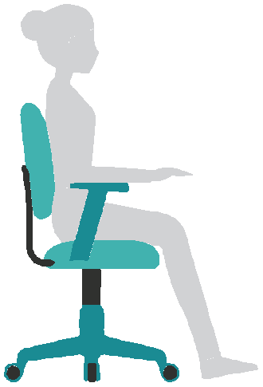 | Chair  Adjust the chair’s back to support the inward curve of your lower back. Adjust your seat height so your thighs are parallel with the floor.  Make sure there is at least 1 inch between the edge of the seat and the back of your knees. Adjust your armrests so that your arms sit comfortably at your sides with your shoulders relaxed.
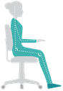 | Feet and Legs  - Sit with your feet flat on the floor.  - If needed, use a footrest as support if your chair is raised.  - Avoid crossing your legs.
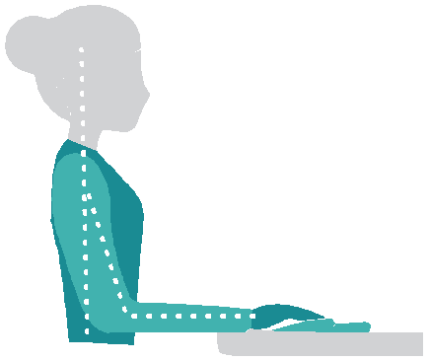  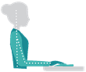 | Keyboard Position  Your keyboard should be at the same height as your elbows. (May need to adjust chair height). With shoulders relaxed, bend your elbows to comfortably reach the keyboard. Your elbows should naturally bend to form a 90° angle. Make sure your keyboard is close enough that you do not need to reach out to touch the keys. Avoid laying forearms or elbows on surfaces to reduce pressure.
Mouse  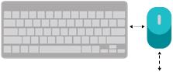 |  | Monitors  
Place your mouse immediately next to the computer keyboard and place both keyboard and mouse close to the front of the desk surface |  | - Position monitor height so top of monitor is slightly above eye level.  - If you have two monitors (same size) AND  - If one is dominant (used 70% or greater), place directly behind keyboard.

Wrist Position |  | 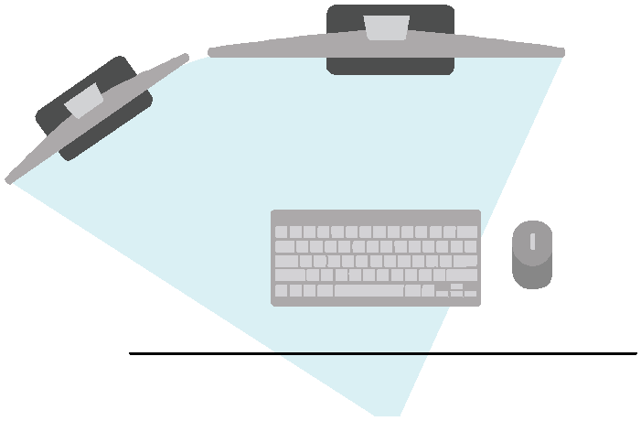
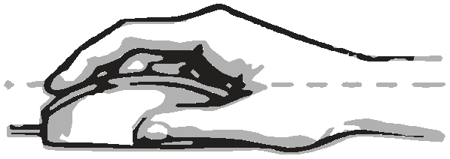  RIGHT |   WRONG!  
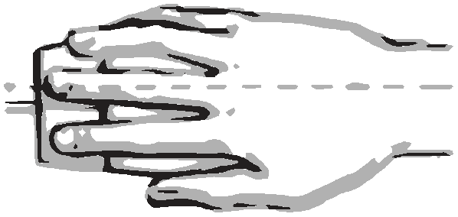  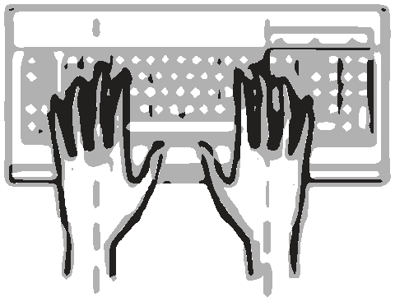  RIGHT  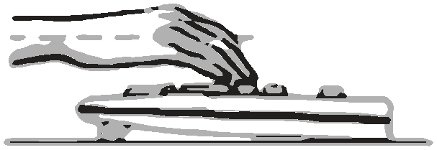 |   WRONG!    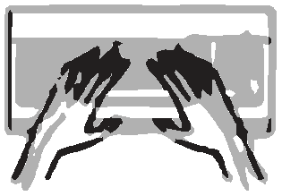  WRONG  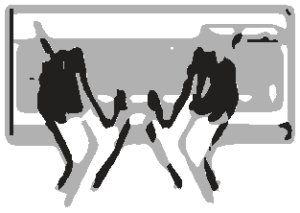  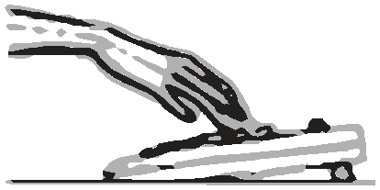  WRONG!   | - If monitors are used equally, position in inverted shallow “v” to reduce neck rotation.  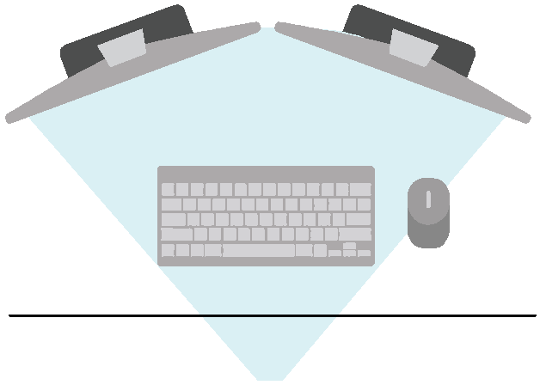  Phone & Frequently Used Materials  Place all frequently used materials within easy reach (generally easy reach does not require a full arm extension while sitting back in chair)  - Use a headset or speaker phone for long conversations or when entering data (so hands are free)  - Avoid cradling the phone by bending your neck between your shoulder and ear while talking and multitasking
- Make sure that your wrists are straight and parallel to the floor.
- Avoid flexing your wrists upward or bending them downwards
- Avoid rotating wrists inward and outward during keystroke entry and mouse use.

Micro/Muscle Breaks & Stretching  Note: If you have had any recent health problems, injury, or surgery, or if any of these actions cause you any pain, consult a health professional before starting this program.  - “Micro/Muscle’ breaks are recommended for every 35-45 minutes of work and should last 2-3 minutes. This allows the muscles you are using to get a short rest break.  - Example stretching exercises. | 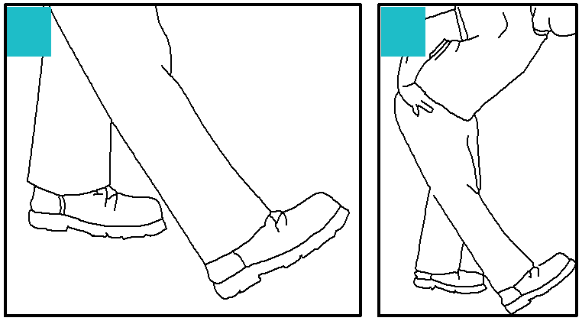  Hamstring Stretch  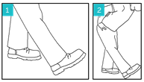  - Place your heel on the ground in front of you with knee straight. You may wish to stand next to something for balance.  - Keep your back straight, look up at the ceiling, and bend forward at your hips.  - Hold for 10-15 seconds. You should feel a mild pulling sensation. If you experience discomfort, then perform the stretch more gently or with your foot on the floor.
Finger and Wrist Flexor Stretch  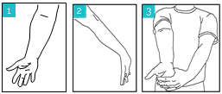  - Straighten your elbow with palm up.  - Point your fingers toward floor.  - Use your other hand to gently pull down on your palm and fingers  - Hold for 10-15 seconds. You should feel a mild pulling sensation. If you experience discomfort, then perform the stretch more gently or go back to the previous step. | 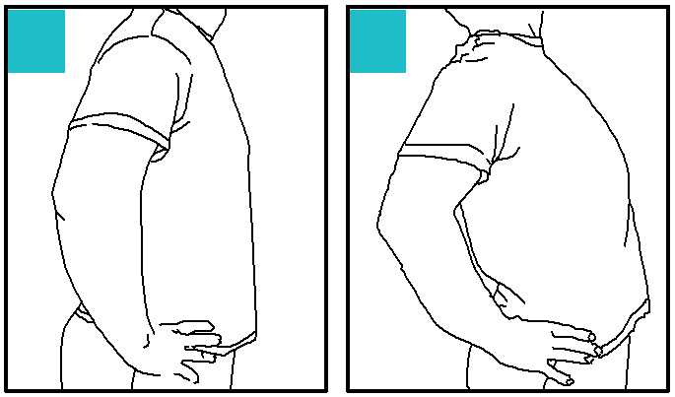  Low Back Flexor Stretch  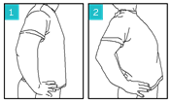  - Place your hands on your hips.  - Gently lean back.  - Hold for 10-15 seconds. You should feel a mild pulling sensation. If you experience discomfort, then perform the stretch more gently or go back to the previous step.
Finger and Wrist Extensor Stretch  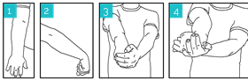  - Straighten your elbow with palm down.  - Bend your wrist down and make a gentle fist. If you feel discomfort in the back of your hand, then relax your fingers.  - Gently pull down on the back of your hand.  - Rotate your arm so that your hand is pointing away.  - Hold for 10-15 seconds. You should feel a mild pulling sensation. If you experience discomfort, then perform the stretch more gently or go back to the previous step. | 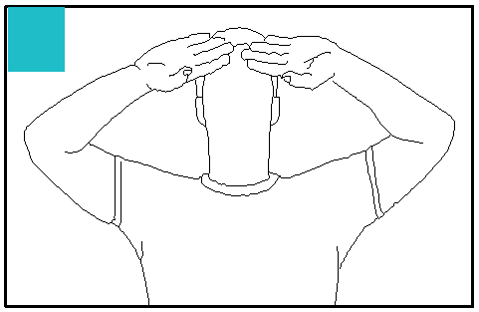  Neck shoulder Stretch  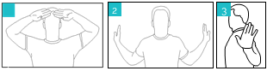  - Place hands in front of forehead with palms facing out. Take a deep breath in.  - Pull elbows toward back pockets while rotating palms out.  - Slowly exhale while squeezing shoulder blades together and drawing head back.  - Once you have fully exhaled, hold for 10-15 seconds. Repeat 2 more times. If you experience discomfort, then perform stretch more gently or go back to the previous step.

